LOCAL GOVERNMENT ACT 1972
Burnham Market Parish Council Meeting

Location: The Village Hall, Burnham Market
Time & Date: Wednesday 4th March 2026 | 18:30
Present: Cllr Fiona Walker (FW) Chair, Cllr Angus Piper (AP), Cllr Peter Smith (PS), Cllr Vicky Davies (VD), Cllr David Cressy (DC). Clerk/RFO Annalisa Dovey: Minutes. Members of public approx. 7
Minutes
- Chair opens the meeting and welcomes everyone at 19:00
- Apologies for Absence: council resolved to accept apologies from Cllr Keith Morris
Carried
- Declarations of Interest and requests for Dispensations: none
- Public Participation Time: Chair adjourned meeting to open for public comments and there were no public comments.
- Past Minutes: Council resolved to approve the minutes from January 2026 PC meeting as accurate.
Carried
Chair e-signed
- To receive non-quorate meeting report: Council noted that the latter part of the January meeting became inquorate and considered the following recommendations from then.
  - Council resolved to stay with Unity Bank and accept the fee and protection increases
Carried
  - Council resolved to ratify the request for donation from the Craft Fair for SAM3 road safety project and playground repair, made under delegated authority by the clerk
Carried
  - Council resolved to approve Clerk’s December 2025 annual appraisal
Carried

  - Council resolved to reject proposal to install a pedestrian crossing sign at Whiteways
Carried
- Matters Arising: Any updates from councillors / Clerk on matters in past minutes
  - Green Gate: Council heard that the lock on the playing field roadside green gate has been installed and the clerk holds the code (in the clerk’s handbook) and resolved to ratify this delegated decision and spending. Install a lock on the Green Gate
Carried

  - Playground bench: Council resolved to ratify delegated decision to repair the bench in the playground and heard that this had been completed.
Carried
- Borough Councillor Report: Council heard updates from Borough Cllr Sam Sandell
  - Anglia Water are objecting to all planning applications
    - Heacham sewage works is already over capacity and releasing sewage regularly into the sea and Anglia water say that any additional flow would be an unacceptable risk to the environment.
  - The New Local Plan will require a doubling of housing quotas to 1000 and must be ready in 30months.
    - The call for sites has begun.
  - Borough has a £250,000 funding pot, apply by email to Cllr Sam Sandell. Projects must be well thought out.
  - Anglia Water has help with bills grants available for anyone with bladder problems. Dialysis etc.
  - LGR currently is not proceeding due to elections; there is no guarantee that incoming members will continue LGR on, so it Is not possible to start
ACTION: include Anglia water funding for bladder problems/ dialysis in Newsletter
- County Councillor Report: Council received apologies from Cllr Andrew Jamieson and confirmed that emailed reports have been received.
- Councillor Reports: To receive reports and updates from councillors
  - DC attended training and found meeting other Councils and councillors beneficial.
  - Noted Burnham Market is short of graveyard space, and this is something the PC may need to consider.
ACTION: Clerk to investigate graveyard space and the powers that relate to it. (report on April meeting)
- Clerk’s report: To receive update from Clerk and consider any requests
  - Noted: AdvantEdge has not been working with very limited access following a Microsoft update that has knocked connectivity. It appears to be back online now with a new log in format to address issues.
  - National Trails sign: Reported that there has been no interest from Traders in using or updating the National Trails sign board.
  - Pensions regulator: Reported that Ewings has refreshed registration with the pension’s regulator.
  - Data security: Council resolved to approve the purchase of an external hard drive to back up files in case of computer failure (budget £75)
Carried
  - Asset purchase: Council resolved to purchase phone case and screen for clerk phone (budget £20)
Carried
  - Playing field wall damage – No update yet.
  - Tree inspection: Council resolved to ask Holkham if they would be carrying out a Tree survey and if so, please could we have the copy, and otherwise, budget approved (£200) to commission a tree survey.
Carried
  - Bookings for Pavillion & Greens and Playing field: Council resolved to begin investigating an online bookings process. Clerk to explore.
Carried
  - Victorian Lamp posts: Council hear the 2 damaged Victorian lamp posts will be repaired by 27th Feb.
ACTION: purchase external hard drive and commence back up regime.
ACTION: purchase phone case and screen protector.
ACTION: chase Holkham on Playing field wall
ACTION: Find out answers on tree responsibility and arrange inspection as required.
ACTION: ask Heronwood to repair new broken post on the green.
- Late items: Council resolved to waive the 5-day notice period for the following items
  - Post on the green: Council resolved to ask Heronwood to repair the post in the green.
Carried
  - Audit date. Council resolved to accept internal audit date of 23rd April
Carried
- Flooding & Water
  - Council noted Anglia Water meeting report circulated by email: Survey / complex investigations.
  - FAG Correspondence: Council noted correspondence received from FAG and resolved to:
  - Decline to seek funding for the Low Bridge proposal
Carried
  - Take no further action on request to speak to expert on Low bridge project
Carried
  - Decline request for council open a bank account for FAG
Carried
  - Decline request for Clerk to act as administrator for FAG
Carried
  - Note and take no further action on Flooding Footbridge Photos
Carried
  - Anglia water: Council noted the dispute between Borough Planning and Anglia Water with Borough saying Anglia Water has a statutory obligation to provide services and Anglia water saying they simply cannot until 2030. Council noted concerns that parishioners, residents and the environment will shoulder a negative the impact of Borough insists on more development.
    - Council resolved to write to MP James Wild, Borough Planning and Anglia Water to highlight concerns and ask for solutions to be considered urgently and carefully.
Carried
  - Environment Agency Works: Council received the Environment Agency notification of works to Lower & Upper Burn and heard those has been placed on Facebook and the Parish Council website.
ACTION: DC & Clerk to draft Anglia Water concerns letter and circulate before sending
- 2026 – 2027 Meeting dates: Council considered 2026-2027 dates and resolved the following schedule: first Wednesday of each month except August, November, January & February. Noted importance of having budget and precept agreed in December.
Carried.
Wednesday 8th April 2026 End of Year Financial Reports & Asset check report (not 1st April as the End of Year is important)
Wednesday 6th May 2026 (AGM)
Wednesday 3rd June 2026 Internal / External Audit papers
Wednesday 8th July 2026
August – NO meeting
Wednesday 2nd September 2026 Asset Check report
Wednesday 7th October 2026 draft budget / project lists
Wednesday 2nd December- Agree Budget and Precept
January – No Meeting
February – No Meeting
Wednesday 3rd March 2027
Wednesday 7th April 2027
Wednesday 5th May 2027 AGM

- Internal Controls Officer: Council resolved it has insufficient capacity to have an internal controls officer and to review this should number increase.
Carried
- Bank signatories: Council resolved to approve Cllr Vick Davies as. Bank signatory in place of Cllr Fiona Walker.
Carried
- Sallys Bakes & Cakes: Council resolved to approve Sallys Bakes & Cakes request to be on the Green to raise funds for Heritage House and as it is a charitable concern, agreed to waive any fees.
Carried
- Delegated Planning Decisions: Council resolved to ratify the following planning application responses made under delegated authority.
- 25/02162/F: Variation of condition 2 attached to planning permission 23/00496/FM: The erection of 12 dwellings - Land Opposite 1 To 4 Beacon Hill | NO OBSERVATION
Ratified – carried.
- 26/00068/LDE: LAWFUL DEVELOPMENT CERTIFICATE: Existing use of the outbuilding as residential accommodation at The Gazebo 57 Market Place. | Insufficient Information
VD recused | Ratified – carried
- 26/00098/LB: variation of Condition 2 attached to Listed Building Consent Change of use from Art Gallery to residential with small extension at St Andrews Cottage No observation
Ratified – carried
- 26/00123/F HOUSEHOLDER: Proposed extensions and alterations including the provision of a first floor at The Bungalow Creake Road
Ratified – carried
- Council noted the following KLWNBC decisions
  - 5/01501/NMA_1| Angles Lane Bungalow | NON-MATERIAL AMENDMENT to Planning Permission 25/01501/F: Variation of Condition 2 of Planning Permission 24/01935/F: SELF BUILD: Replacement of existing bungalow, mobile home and outbuildings, with new house | Application Refused
  - SNN4 – 5790 | Change of Residential Property Address: From The Gardens, Overy Road, to Overy House, Overy Road.
  - 5/02020/F | External and internal alterations and decoration to merge 2 class E units and replacement of first floor UPVC window to timber 60 And 61 Market Place - Permitted
  - 5/02089/LB LISTED BUILDING: Attachment of 6 hanging basket brackets to the front elevation The Hoste Arms | Permitted

- Planning Applications: council consider the following applications and resolved to respond with:
  - No observation: 26/00157/F HOUSEHOLDER: Erection of a two-storey side extension with Hippeo Subservient roof, a single storey rear extension with a pitched roof, and a new porch to an existing semi-detached dwelling using materials to match existing. at 11 Walkers Close Creake Road Burnham Market King's Lynn Norfolk PE31 8EP
Carried| 4 for – 1 abs

  - Support: 26/00233/A Application for advertisement consent for traditional style signage to fascia and glazed shopfront, 2 x non illuminated fascia signs and 1 x other sign at Jack Wills 16 Market Place Burnham Market
Carried
  - No observation: 26/00219/F VARIATION OF CONDITION 1 OF PLANNING PERMISION 25/01086/F: Variation of condition 2 of planning consent 24/00131/F: Application for change of use from an art gallery and residential dwelling to residential dwelling with extension at Grapevine Gallery St Andrews Cottage Overy Road
Carried
  - No observation: 25/00429/F: Variation of conditions 2, 3, 6, 7, 10, 11, 12, 15, 16, 19 and 20 of planning permission 23/01663/F: VARIATION OF CONDITIONS 2, 3, 4, 5 AND 18 OF PLANNING PERMISSION 20/01866/F: Residential development of 9no. dwellings.at Land at Sutton Estate
Carried
  - Support: 26/00241/LB Listed Building Application: Remove existing signage and install new signage to the facade of the listed building at Jack Wills 16 Market Place Burnham Market King's Lynn Norfolk PE31 8HE
Carried
- Late planning Applications: None to consider
- National Planning Framework: Council note the consultation responses deadline 10th March 2026
- Assets: Playground inspection: Council received monthly report for January 2026 and February 2026, hearing that everything is okay apart from:
  - New handrails require wood treatment: Council resolved to treat wood and request of Richard Newstead
Carried
  - Dented manhole cover: Council resolved that clerk to investigate responsibility and return to council with information
Carried
ACTION: Clerk to arrange wood treatment of Tractor handrails with Richard Newstead
ACTION Clerk to investigate Manhole cover repair solution.
- Assets Allotments: Council heard that all outstanding payments have been made excepting 1 – who has left.
- Assets: Defib: Council resolved to approved purchase of defib case and carry case (£588) and installation
carried
Action: clerk to purchase defib carry case and wall case and arrange installation.
- Assets: Church Walk bus stop: Council approved £25 bus stop floor clean.
Carried
ACTION: clerk to arrange church walk bus stop [ clean with Heronwood as per £25 quote
Finance: End of January Report from Finance Group – Delegated Decisions
- Council received end of January balances: £51,658. 93
- Council resolved to ratify Finance group approval of payments made in January.
Carried
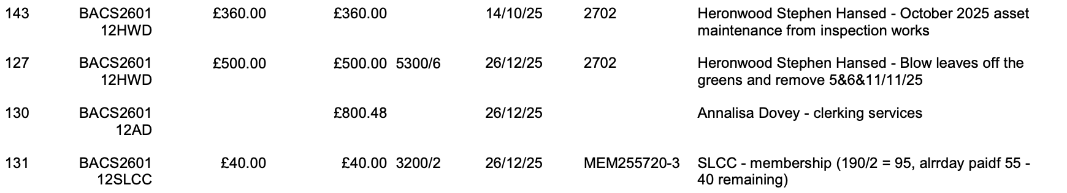
- Council resolved to ratify expenditure in February 2026 made under Delegated Authority by clerk following Financial Group approval.
Carried
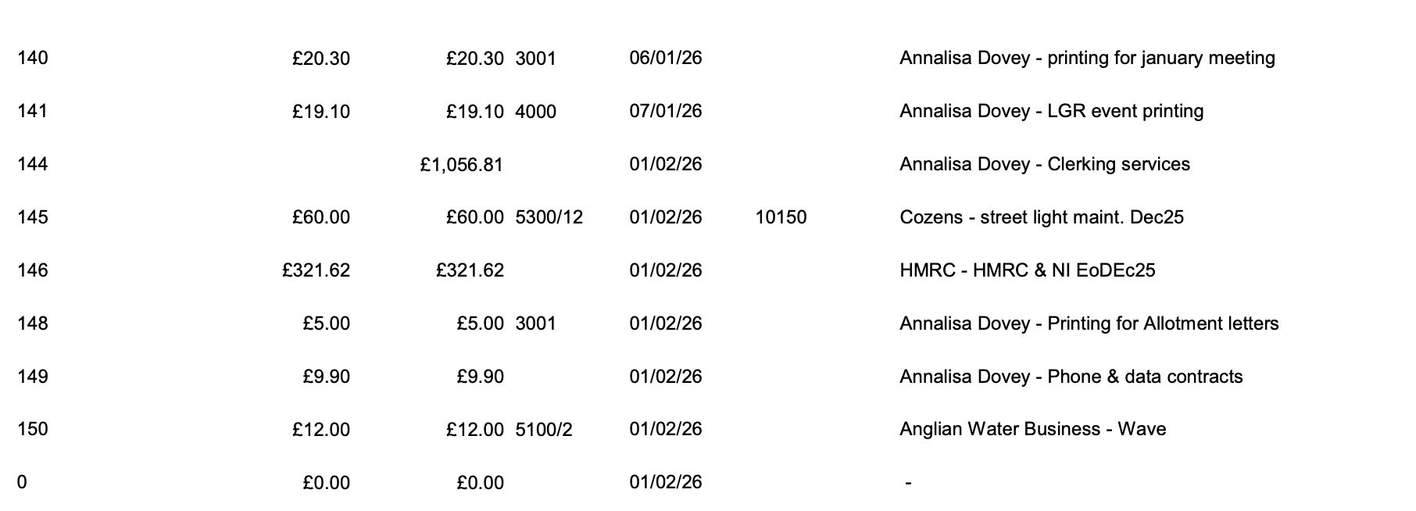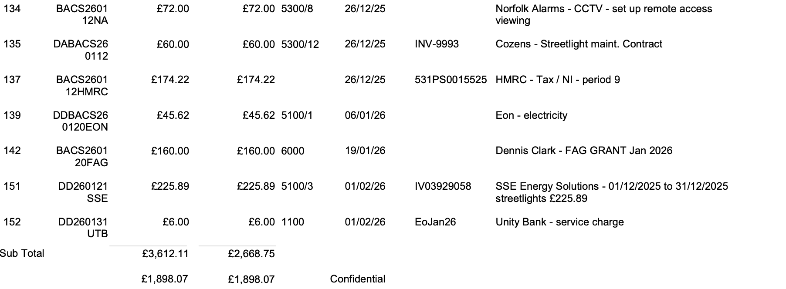
- Finance: End of January & February 2025 Financial Report
- Council received End of February 2026 total account balances £42158.68
- Council received and resolved to approve reconciliations for end of January end of February 2026
Carried
- Council ratified payments made in February by direct debit, delegated authority and following approval by Finance group
Carried
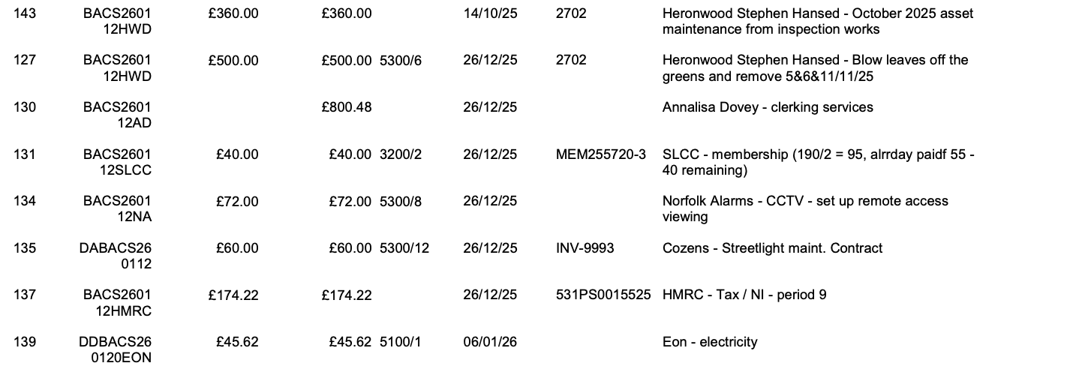
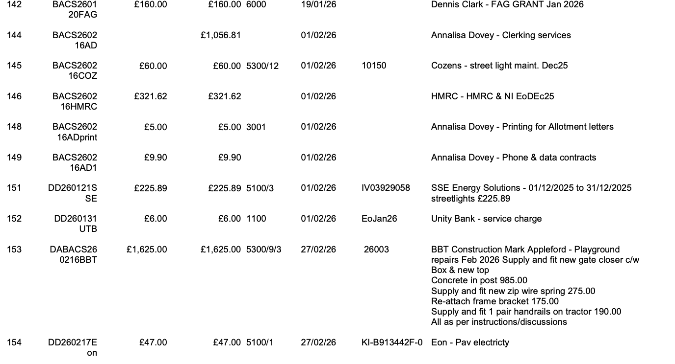
- Council resolved to approve upcoming March 2026 expenditure
Carried
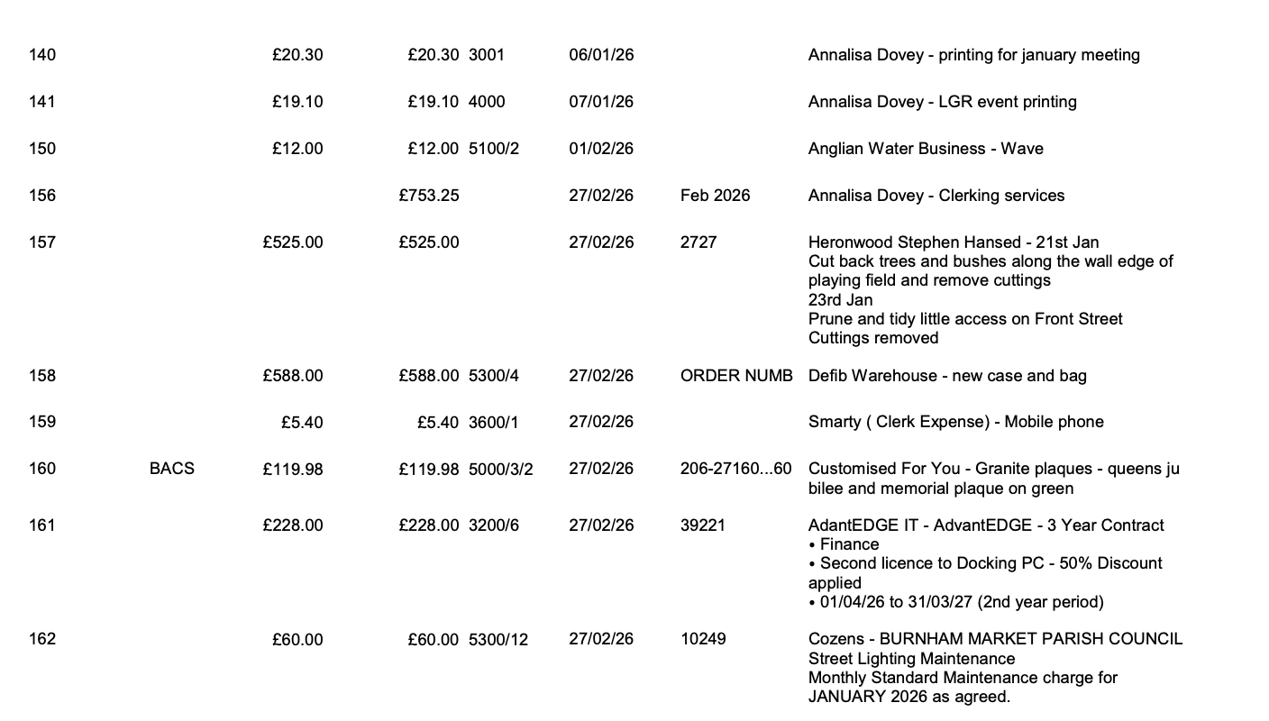
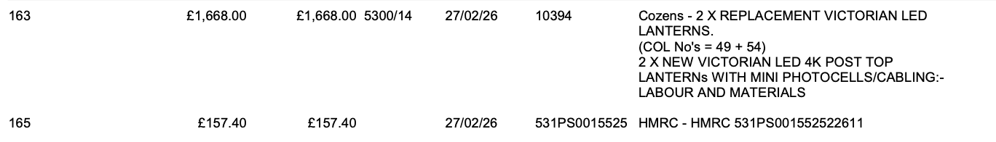
- PIIP & CIL: Council resolved to defer completing PIIP and agreeing and CL project funding until April 2026 PC meeting.
Carried
ACTION: Circulate draft PIIP and work with FW on CIL funding and VD for CL funding for projects and place on April agenda
- Pension Draft Valuation: Council received the pensions valuation and resolved to approve it, and it was signed.
carried
- Donations: council received donation of £1500 from Craft Fair with massive thanks and resolved to place this in the newsletter.
ACTION: Place thanks to craft fair in newsletter
- Bank Interest rates: Council received notification of interest rate reduction 2.10/2.12% - 1.95/1.96% and resolved to remain with Unity Bank
Carried
- Events
  - Auction dates: Council confirmed Auction dates: 22nd June – 14th September 2026 –
  - Additional Craft Fair Council resolved to defer decision on additional craft fair request pending response from Traders and checking 28-day limit
Carried
ACTION: Clerk to produce event tracker to make sure PC does not exceed 28-day limit.
- Correspondence: council confirmed receipt and actions on correspondence received as follows.
  - Correspondence process: Parishoner complaint that directing all emails via clerk is undemocratic: council confirmed this is standard procedure. Confirmed & no further action.
  - Bulk seed orders: Allotment tenant with a bulk order query: already resolved with clerk – Noted & no further action.
- Double Council tax: Parishoner complaint and objection over double council tax: already with Cllr Sam Sandell: Noted and No further action.
- Hill House Contractor: Parishoner: query on Hill House contractor parking: Clerk & DC confirmed that PC request is advisory to planning committee and not necessarily taken up. Any queries on planning should be directed to Borough via enforcement. No further action.
- Village Hall liaison: Parishoner Request that Clerk liaise with Village Hall, clerk not seconded to parishioner admin, parishioner directed to Village Hall contact details. No further action.
- Clerk identity: Parishoner: query on clerk identity and reason for change, council confirmed Clerk A Dovey for over a year now. No further action.

- Public session 2: Council received the following questions and comments from public.
  - 11 walkers close – request that council request a Construction management plan to ensure there is not continuous construction disruption, proposing starting after 8.30 am and finishing by 4pm, with weekends off to allow neighbours respite Verify response with DC prior to sending.
  - Anglia water Inspections: Heard that Anglia water are inspecting residents’ pipes and drains with a sense that Angia water are trying to shift blame,
  - Jack lane wind farm funding is now open for 4 weeks.
  - Cil funding is open: 1st march – 1st may.

- Next Meeting Date: Council agreed next meeting dates 8th April 2026 18:30
Carried
- Meeting closed 20:13

